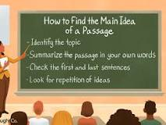

Identify the topic—What is the passage about?

Summarize the passage – Retell it in your own words. If this is difficult, that means you need to read it again closely.

Check the first and last sentences – Very often the main idea is here!

Look for repetition of ideas – If the author is restating a point, then that is a main idea clue.